Erasmus+ (Key Action 1)
Structured Training Course in Madrid and Salamanca, Spain
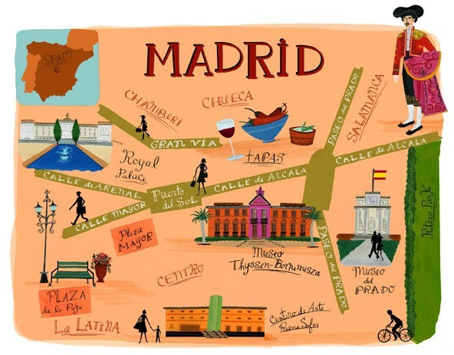
To improve language skills, intercultural understanding, and to share good practice with a partner school
Wednesday 7th – Wednesday 14th April 2021 (Easter holidays)

Who is the course designed for?
The 7 day course is designed for teachers, head teachers, support staff and advisory teachers from the UK who wish to improve their knowledge and understanding of teaching Spanish language and culture. The course will include language immersion, discussions, group tasks, experiencing and sharing good practice in a partner school and cultural and educational activities.

Aims of the course
- To develop knowledge and understanding of the CLIL approach.
- To share good practice
- To increase confidence and competence in the use of the target language in your teaching.
- To access the wealth of cultural landmarks in Madrid and Salamanca to promote the use of the target language, to gather resources, and to inform new units of work.

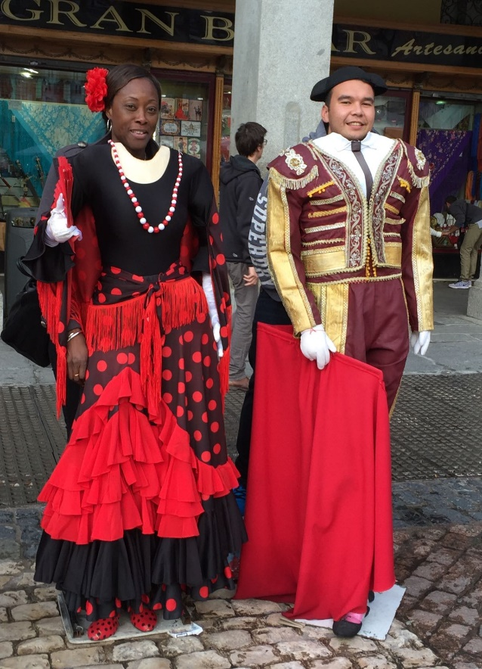
Pre-course Action Plan
Your school will need to draw up a European Development Plan which demonstrates how participation in the overseas course will enhance the professional development of teaching staff.
You must demonstrate that your school has thought about how the experiences undergone on the course will impact on your curriculum.
You will have the chance to observe ways of working in a partner school. Each participant will complete the Europass Language Passport as a baseline assessment of language competence.

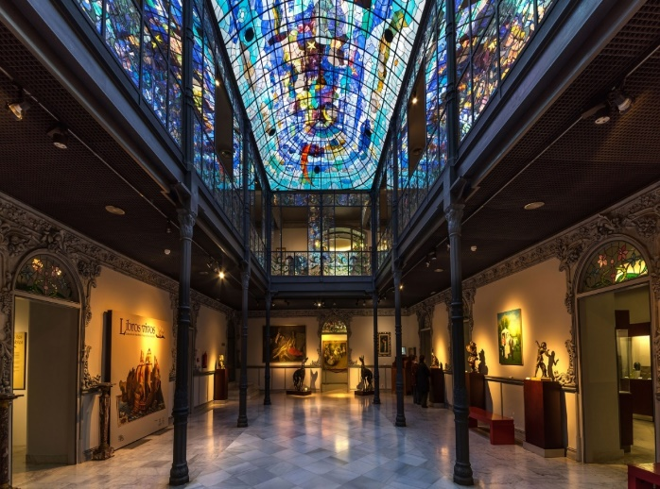

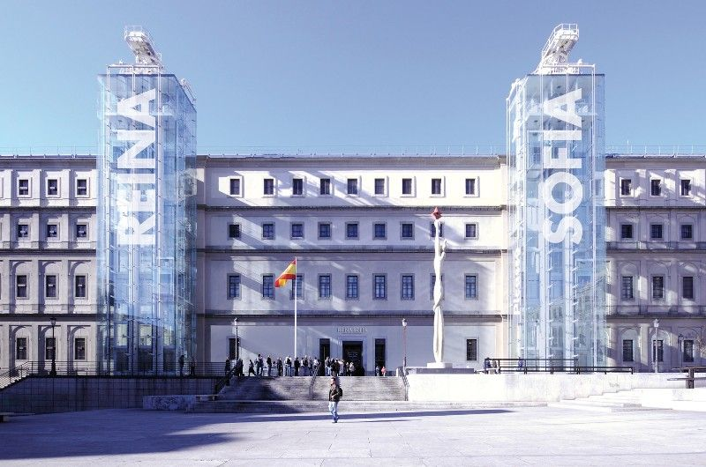
Organisation of sessions
Our approach will encourage participation, sharing of good practice and reflections on your own teaching.

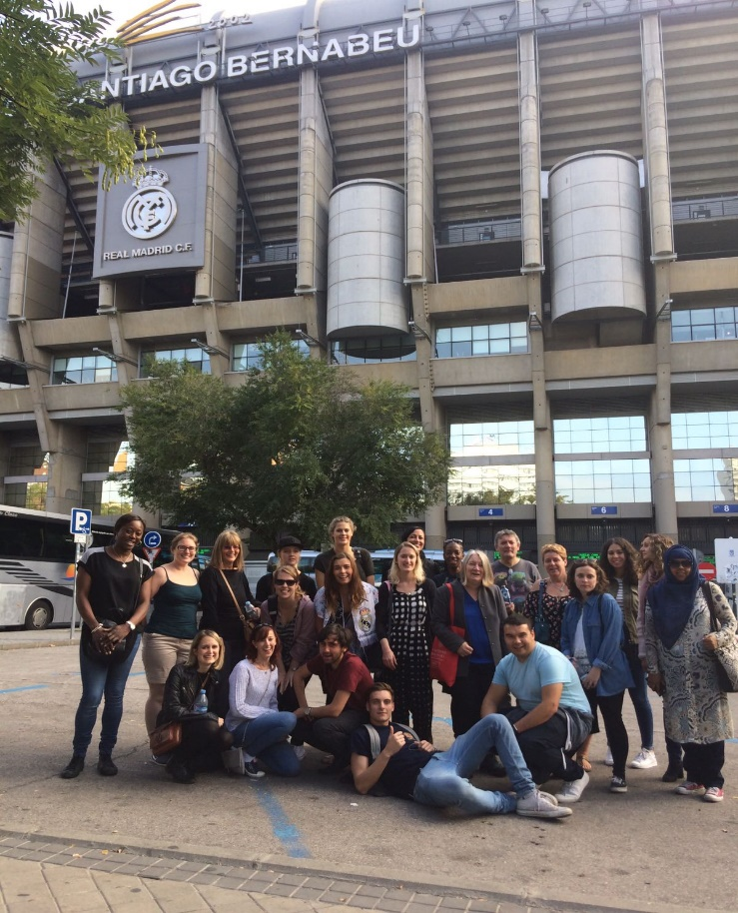
Visit to your partner school
Part of the course will involve you visiting your partner school to observe and share good practice in language teaching. You will also have the chance to plan future activities and projects to maintain a long-term link with the partner school.

Evaluation and Dissemination
There will be a final evaluation on the last day. This will contribute to your end of project report. You will plan how you will disseminate the outcomes to both internal and external audiences.

Post-course Action Plan
Part of the time that you will be in school will involve you in planning and agreeing joint follow up work. At the end of the course, and as part of the evaluation, you will submit your agreed Action Plan.

Course certification
We will provide you with:
- A Course Attendance Certificate (needed as part of evidence).

Day | Madrid & Salamanca Activities
Travel Day  Sunday 12th April 2020 | - Travel to Madrid from London; Coach to Salamanca  - Accommodation at the university  - Orientation around town
Day 1  Monday 13th April 2020 | - Language classes at appropriate level at the university  - Walking tour of Salamanca
Day 2  Tuesday 14th April 2020 | - Language classes at appropriate level at the university  - Visit Museo Casa Lis (Optional)  - Music event TBC
Day 3  Wednesday 15th April 2020 | - AM – Travel back to Madrid  - PM - Visit the Museo Reina Sofía
Day 4  Thursday 16th April 2020 | - Visit partner school – All day  - Evening – Flamenco Show
Day 5  Friday 17th April 2020 | - Visit partner school – All day  - Evening - Visit to the Prado Museum
Day 6  Saturday 18th April 2020 | - AM – Visit to the Real Madrid Stadium  - PM – Walking tour of Central Madrid and Parque Retiro
Day 7  Sunday 19th April 2020 | - AM – Visit to El Mercado Rastro  - PM – Evaluation and presentation of Attendance certificates; Return to London

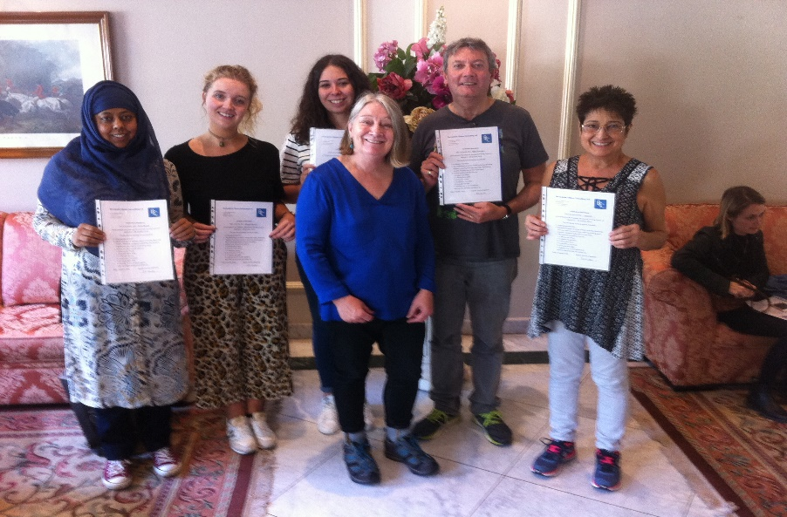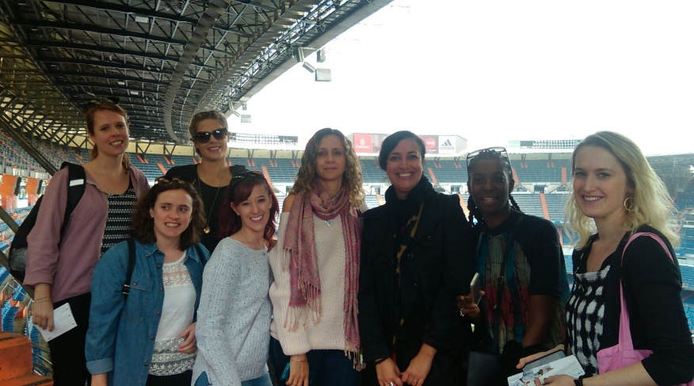

“An excellent cultural experience – would definitely recommend!”
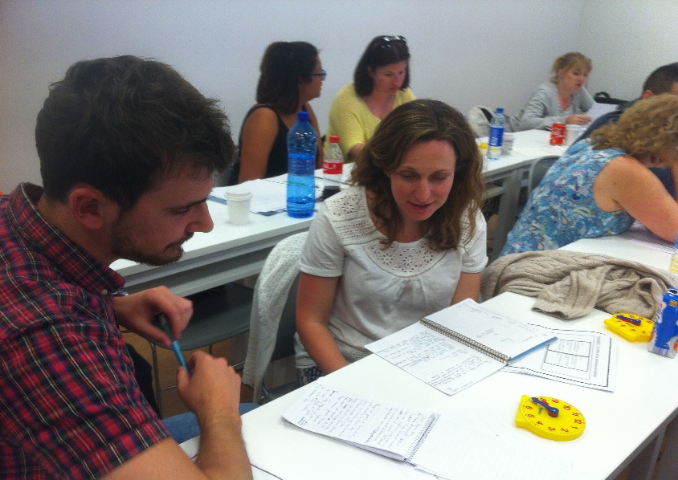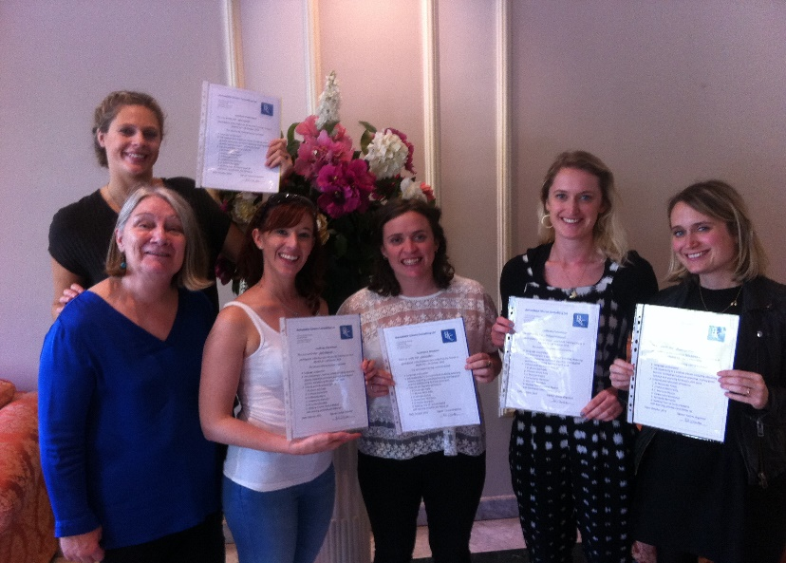
“Great language teacher – very well organised – great range of activities and networking opportunities”

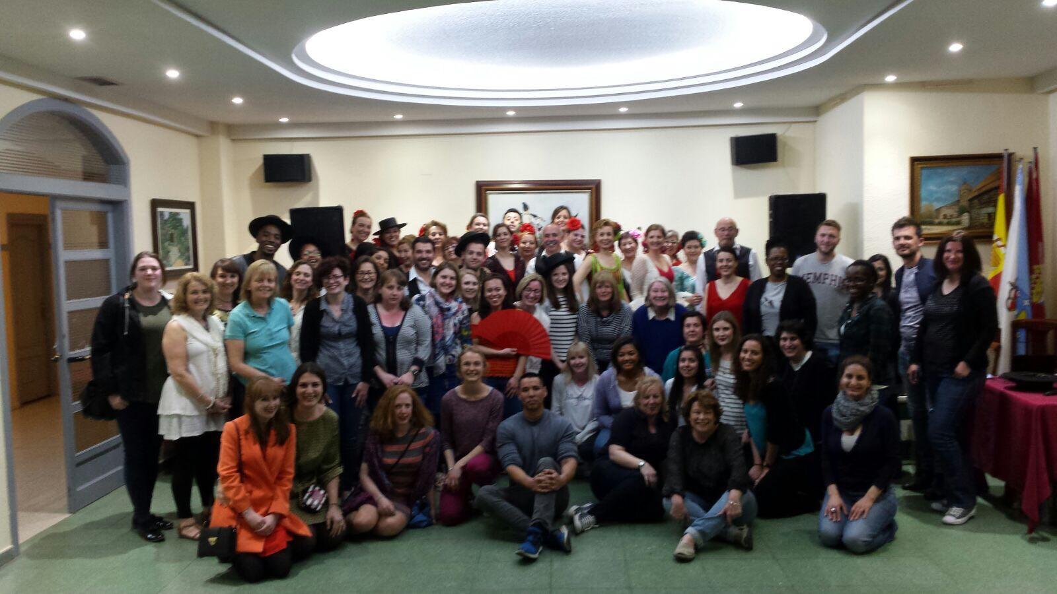

“Culturally and historically very interesting… great to see the contrast between Salamanca and Madrid
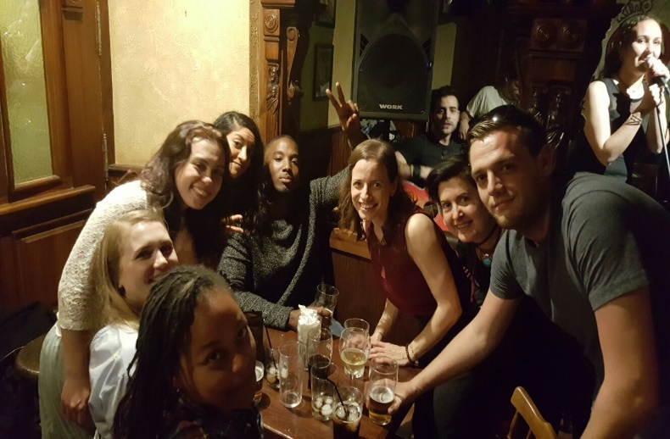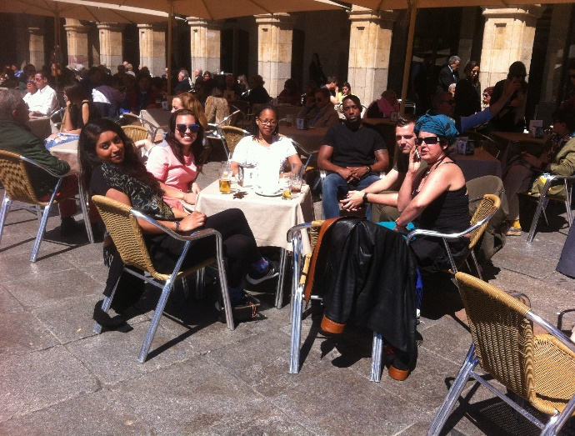

For all further information, please contact:

Bernadette Clinton
www.bcclanguages.co.uk
b.clinton@mdx.ac.uk
@bcclanguages

