Instructions for ‘Heads down, Thumbs up’

1) Chosen pupils stand in front of class clearly showing their picture flashcards. Teacher says the Spanish for each, and the pupils hold up their card.

2) Pupils at their desks are asked to put their heads down and thumbs up.

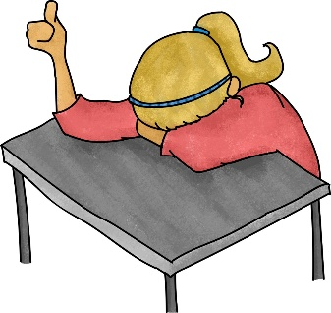

3) The pupils holding the cards quietly go around the class and each touches one pupil’s thumb. That pupil then puts their thumb down.
4) The card holding pupils return to their positions at the front of the class, and the other pupils are asked to put their thumbs down and to stand up, if their thumb was touched.
5) Teacher asks each of the above pupils to say which card holding pupil touched their thumb, by saying the Spanish sentence that goes with their picture. (Text cards for the pictures should be on the board for support). If their guess is correct, that pupil swaps places with the card holding pupil.
6) Any card holding pupil who is still in the line at the end of the round, says which pupil’s thumb they did touch.
7) The game continues.

