**Nombre:** …………………………………………..

**Activity 2**

When you have ordered the sentences read out by the teacher, take it in turns to read them aloud and, if suitable, give feedback to your partner:

Things that you pronounced well:

………………………………………………

………………………………………………

………………………………………………

Things that you can improve on:

………………………………………………

………………………………………………

………………………………………………

Signed: ……………………………………..

**Activity 3**

Translate the sentences into English:

1. ………………………………………

2. ………………………………………

3. ………………………………………

4. ………………………………………

5………………………………………..

**Activity 1**

Spell the 4 words that the teacher reads out:

1. …………………………………….

2. …………………………………….

3. …………………………………….

4. …………………………………….

……..

4. ……………………………………………………..

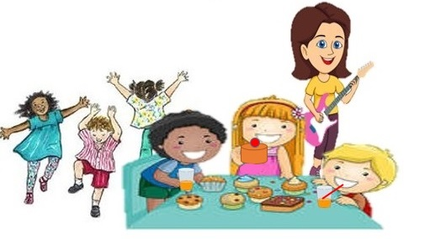

María

**Activity 4**

María is having a party. Complete the following sentences about what the different people in the picture are doing at the party by filling in the gaps with an appropriate verb. You can add more sentences if you wish.

1. La señora……………..la guitarra.

2. María……………una tarta.

3. Los dos chicos sentados a la mesa…………………

zumo de naranja.

4. Los tres chicos al fondo…………………………….

5. ………………………………………………………

6. ………………………………………………………

……..

4. ……………………………………………………..

**Activity 5**

With your partner, make up and perform a dialogue in which you take turns asking and answering questions about what the different people in the picture are doing at the party, Por ejemplo:

Q ¿Qué hace la señora?

A Toca la guitarra.

¿Qué hacen los tres chicos al fondo?

¿Qué bebe el chico con el pelo rubio?