Buying an icecream

Write the Spanish words in the spaces provided:

How would the customer and icecream seller greet each other?

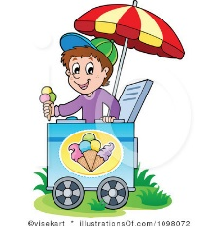
……………………... ……………………..

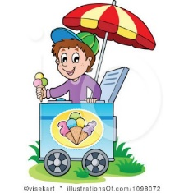
How would the customer ask for an icecream, and what would the icecream seller say as he handed it to him?

………………………… ……………………..

………………………… …………………….

How would the customer say ‘thank you’ and ask for the price, and what would the icecream seller reply?

……………………. ………………………

……………………. ………………………

How would the customer and icecream seller say goodbye to each other?

……………………. ……………………….

Anything else?

……………………. ……………………….

