
Erasmus+ (Key Action 1)
Structured Training Course in Madrid and Salamanca, Spain
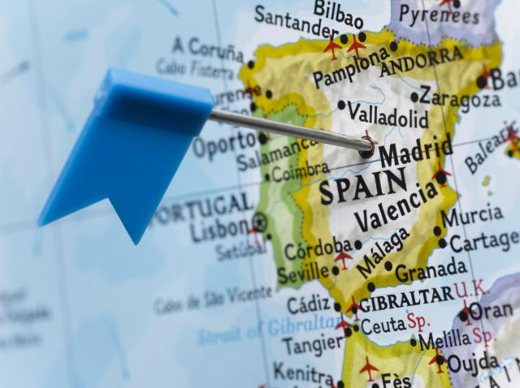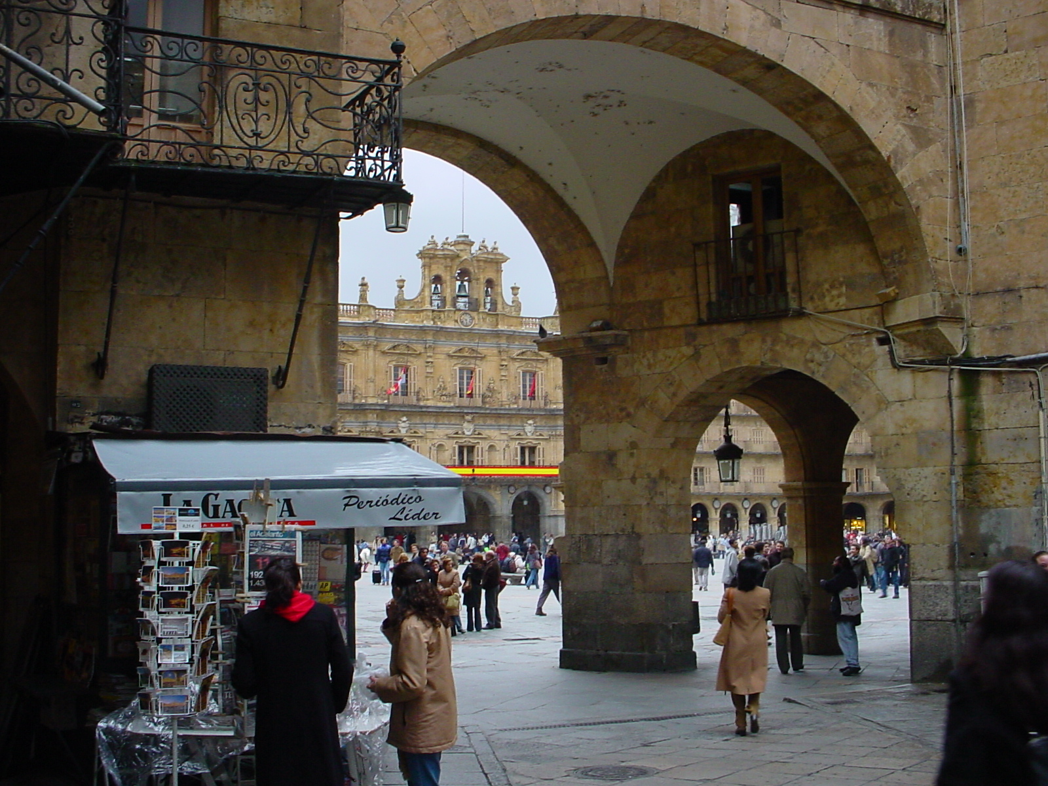
To improve language skills, intercultural understanding, and to share good practice with a partner school
Wednesday 4th – Wednesday 11th April 2018 (Easter holidays)


Who is the course designed for?
The 7 day course is designed for teachers, head teachers, support staff and advisory teachers from the UK who wish to improve their knowledge and understanding of teaching Spanish language and culture. The course will include language immersion, discussions, group tasks, experiencing and sharing good practice in a partner school and cultural and educational activities.

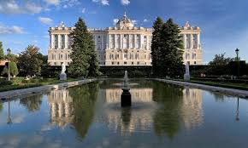


Aims of the course
- To develop knowledge and understanding of the CLIL approach.
- To share good practice
- To increase confidence and competence in the use of the target language in your teaching.
- To access the wealth of cultural landmarks in Madrid and Salamanca to promote the use of the target language, to gather resources, and to inform new units of work.

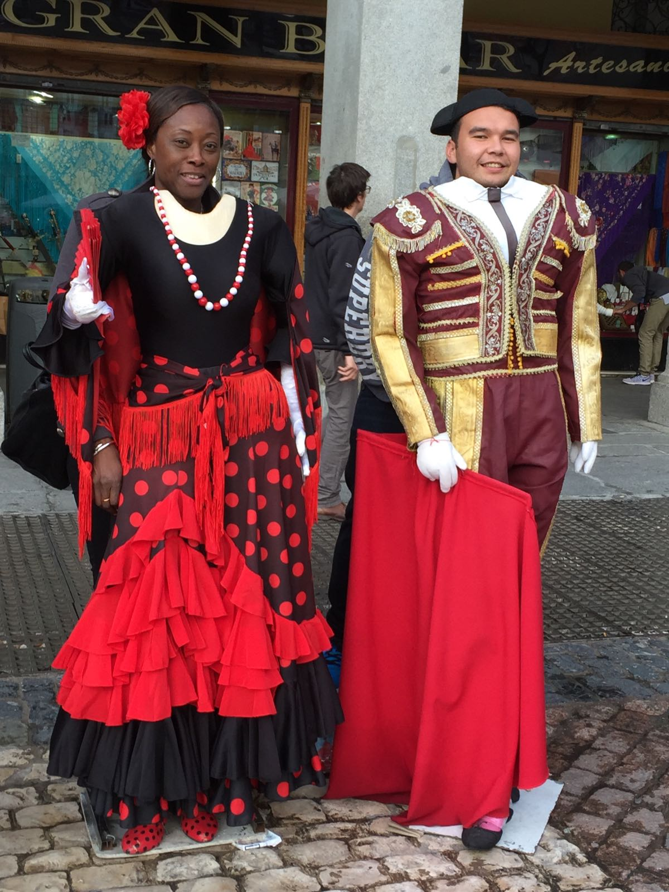
Pre-course Action Plan
Your school will need to draw up a European Development Plan which demonstrates how participation in the overseas course will enhance the professional development of teaching staff.
You must demonstrate that your school has thought about how the experiences undergone on the course will impact on your curriculum.
You will have the chance to observe ways of working in a partner school. Each participant will complete the Europass as a baseline assessment of language competence.

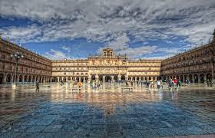

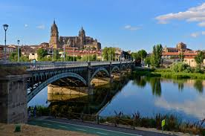
Organisation of sessions
Our approach will encourage participation, sharing of good practice and reflections on your own teaching.

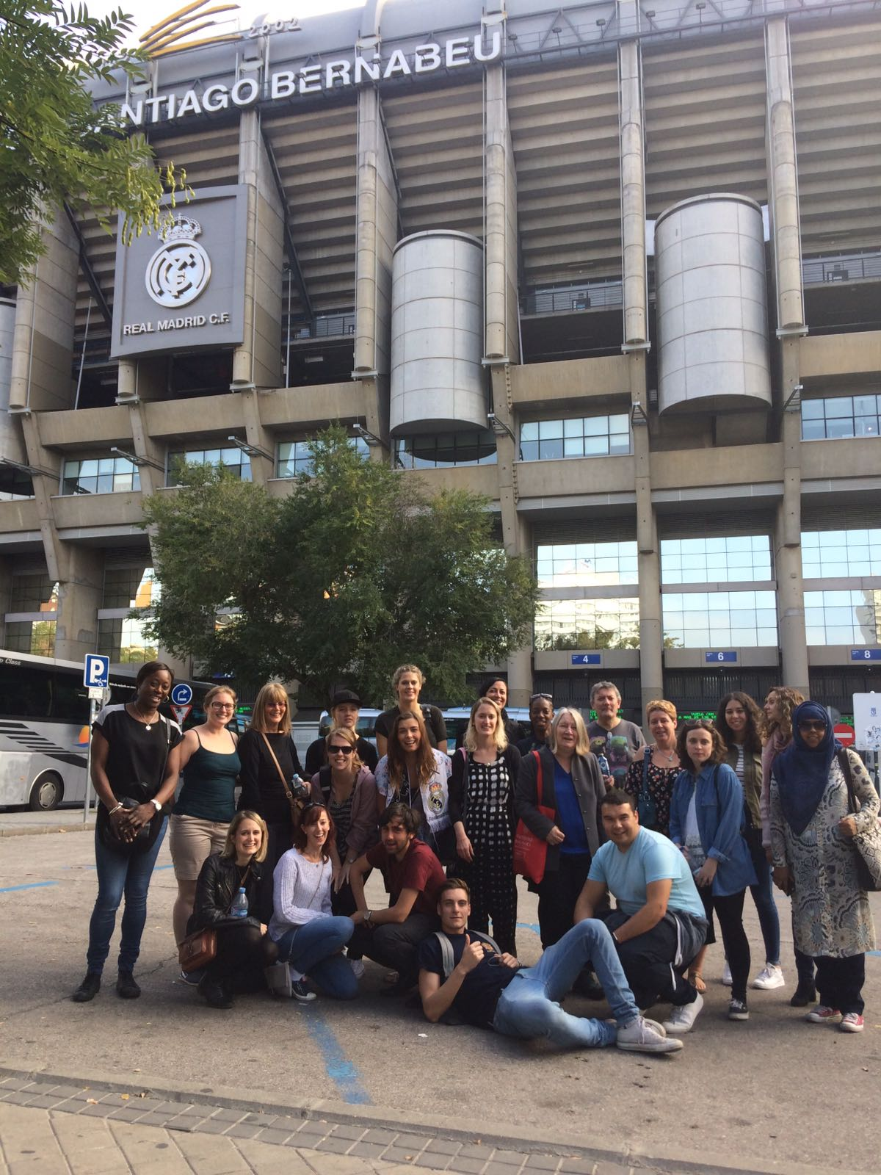
Visit to your partner school
Part of the course will involve you visiting your partner school to observe and share good practice in language teaching. You will also have the chance to plan future activities and projects to maintain a long-term link with the partner school.
Post-course Action Plan
Part of the time that you will be in school will involve you in planning and agreeing joint follow up work. At the end of the course, and as part of the evaluation, you will submit your agreed Action Plan.

Evaluation and Dissemination
There will be a final evaluation on the last day. This will contribute to your end of project report. You will plan how you will disseminate the outcomes to both internal and external audiences.


Course certification
We will provide you with:
- A Course Attendance Certificate

Day | Madrid & Salamanca Programme
Travel Day  Wednesday | Travel to Madrid from Stansted; coach from the airport to Salamanca; check in to your accommodation; Induction meeting; orientation around key places; free evening.
Day 1  Thursday | Language classes to develop own language skills and competence. Music event in evening.
Day 2  Friday | Language classes to develop own language skills and competence.
Day 3  Saturday | Return to Madrid in the Morning. Visit to Museo Reina Sofía. Free Evening
Day 4  Sunday | Visit to The Rastro Market. Visit to The Prado Museo. Walking tour of Madrid.
Day 5  Monday | Visit partner school to observe and discuss CLIL teaching; to present a lesson and to plan joint work. Flamenco show.
Day 6  Tuesday | Visit partner school to observe and discuss CLIL teaching; to present a lesson and to plan joint work. Group meal.
Day 7  Wednesday | Tour of the Estadio Bernabéu. Evaluation and feedback. Depart from Madrid and travel home.

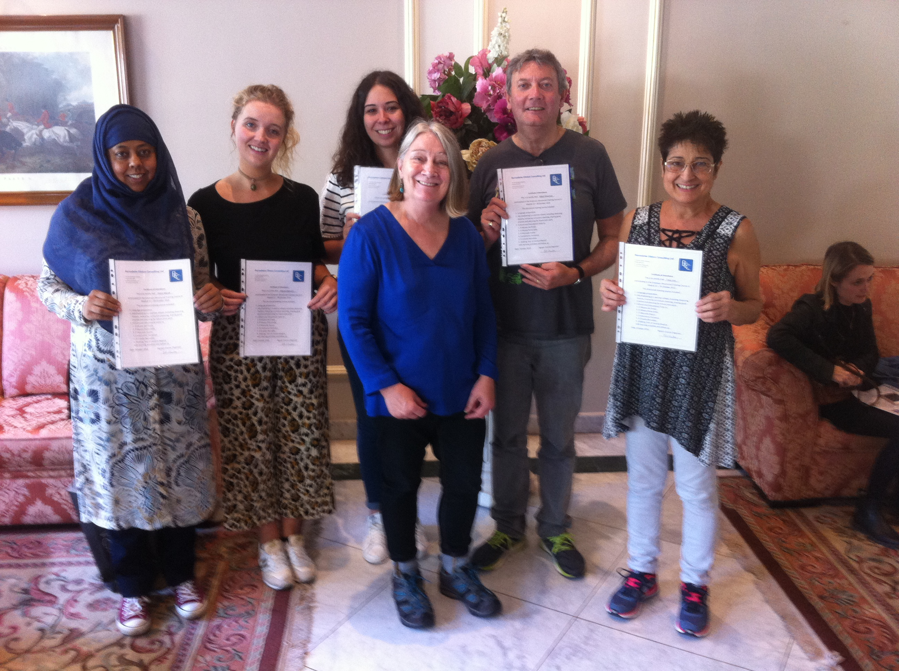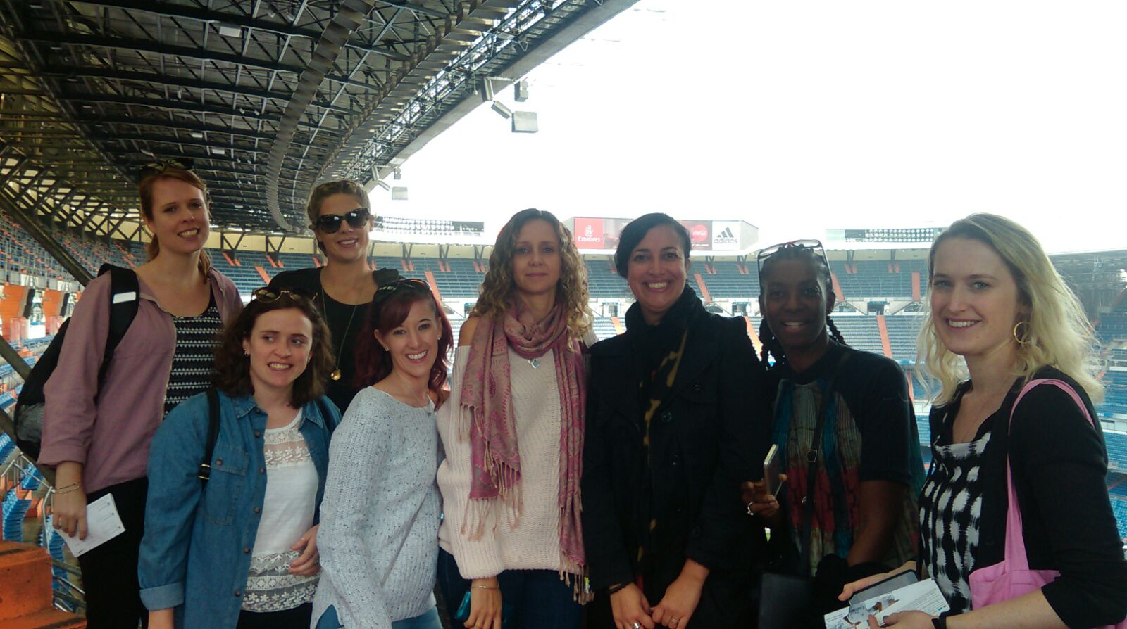
“An excellent cultural experience – would definitely recommend!”
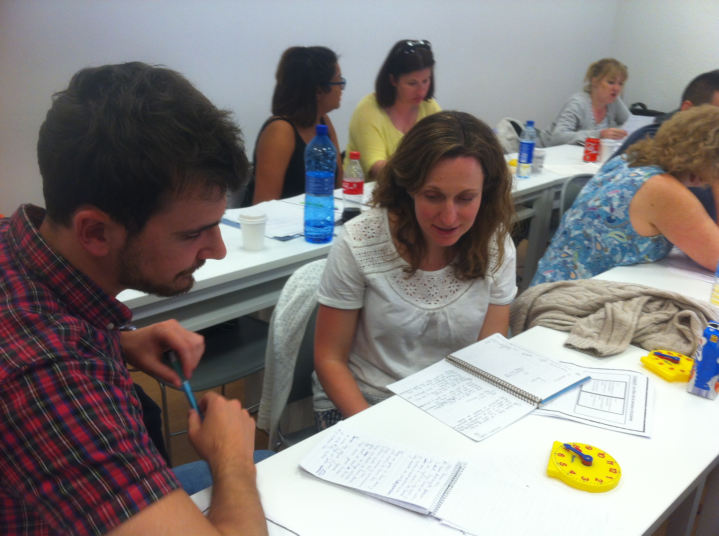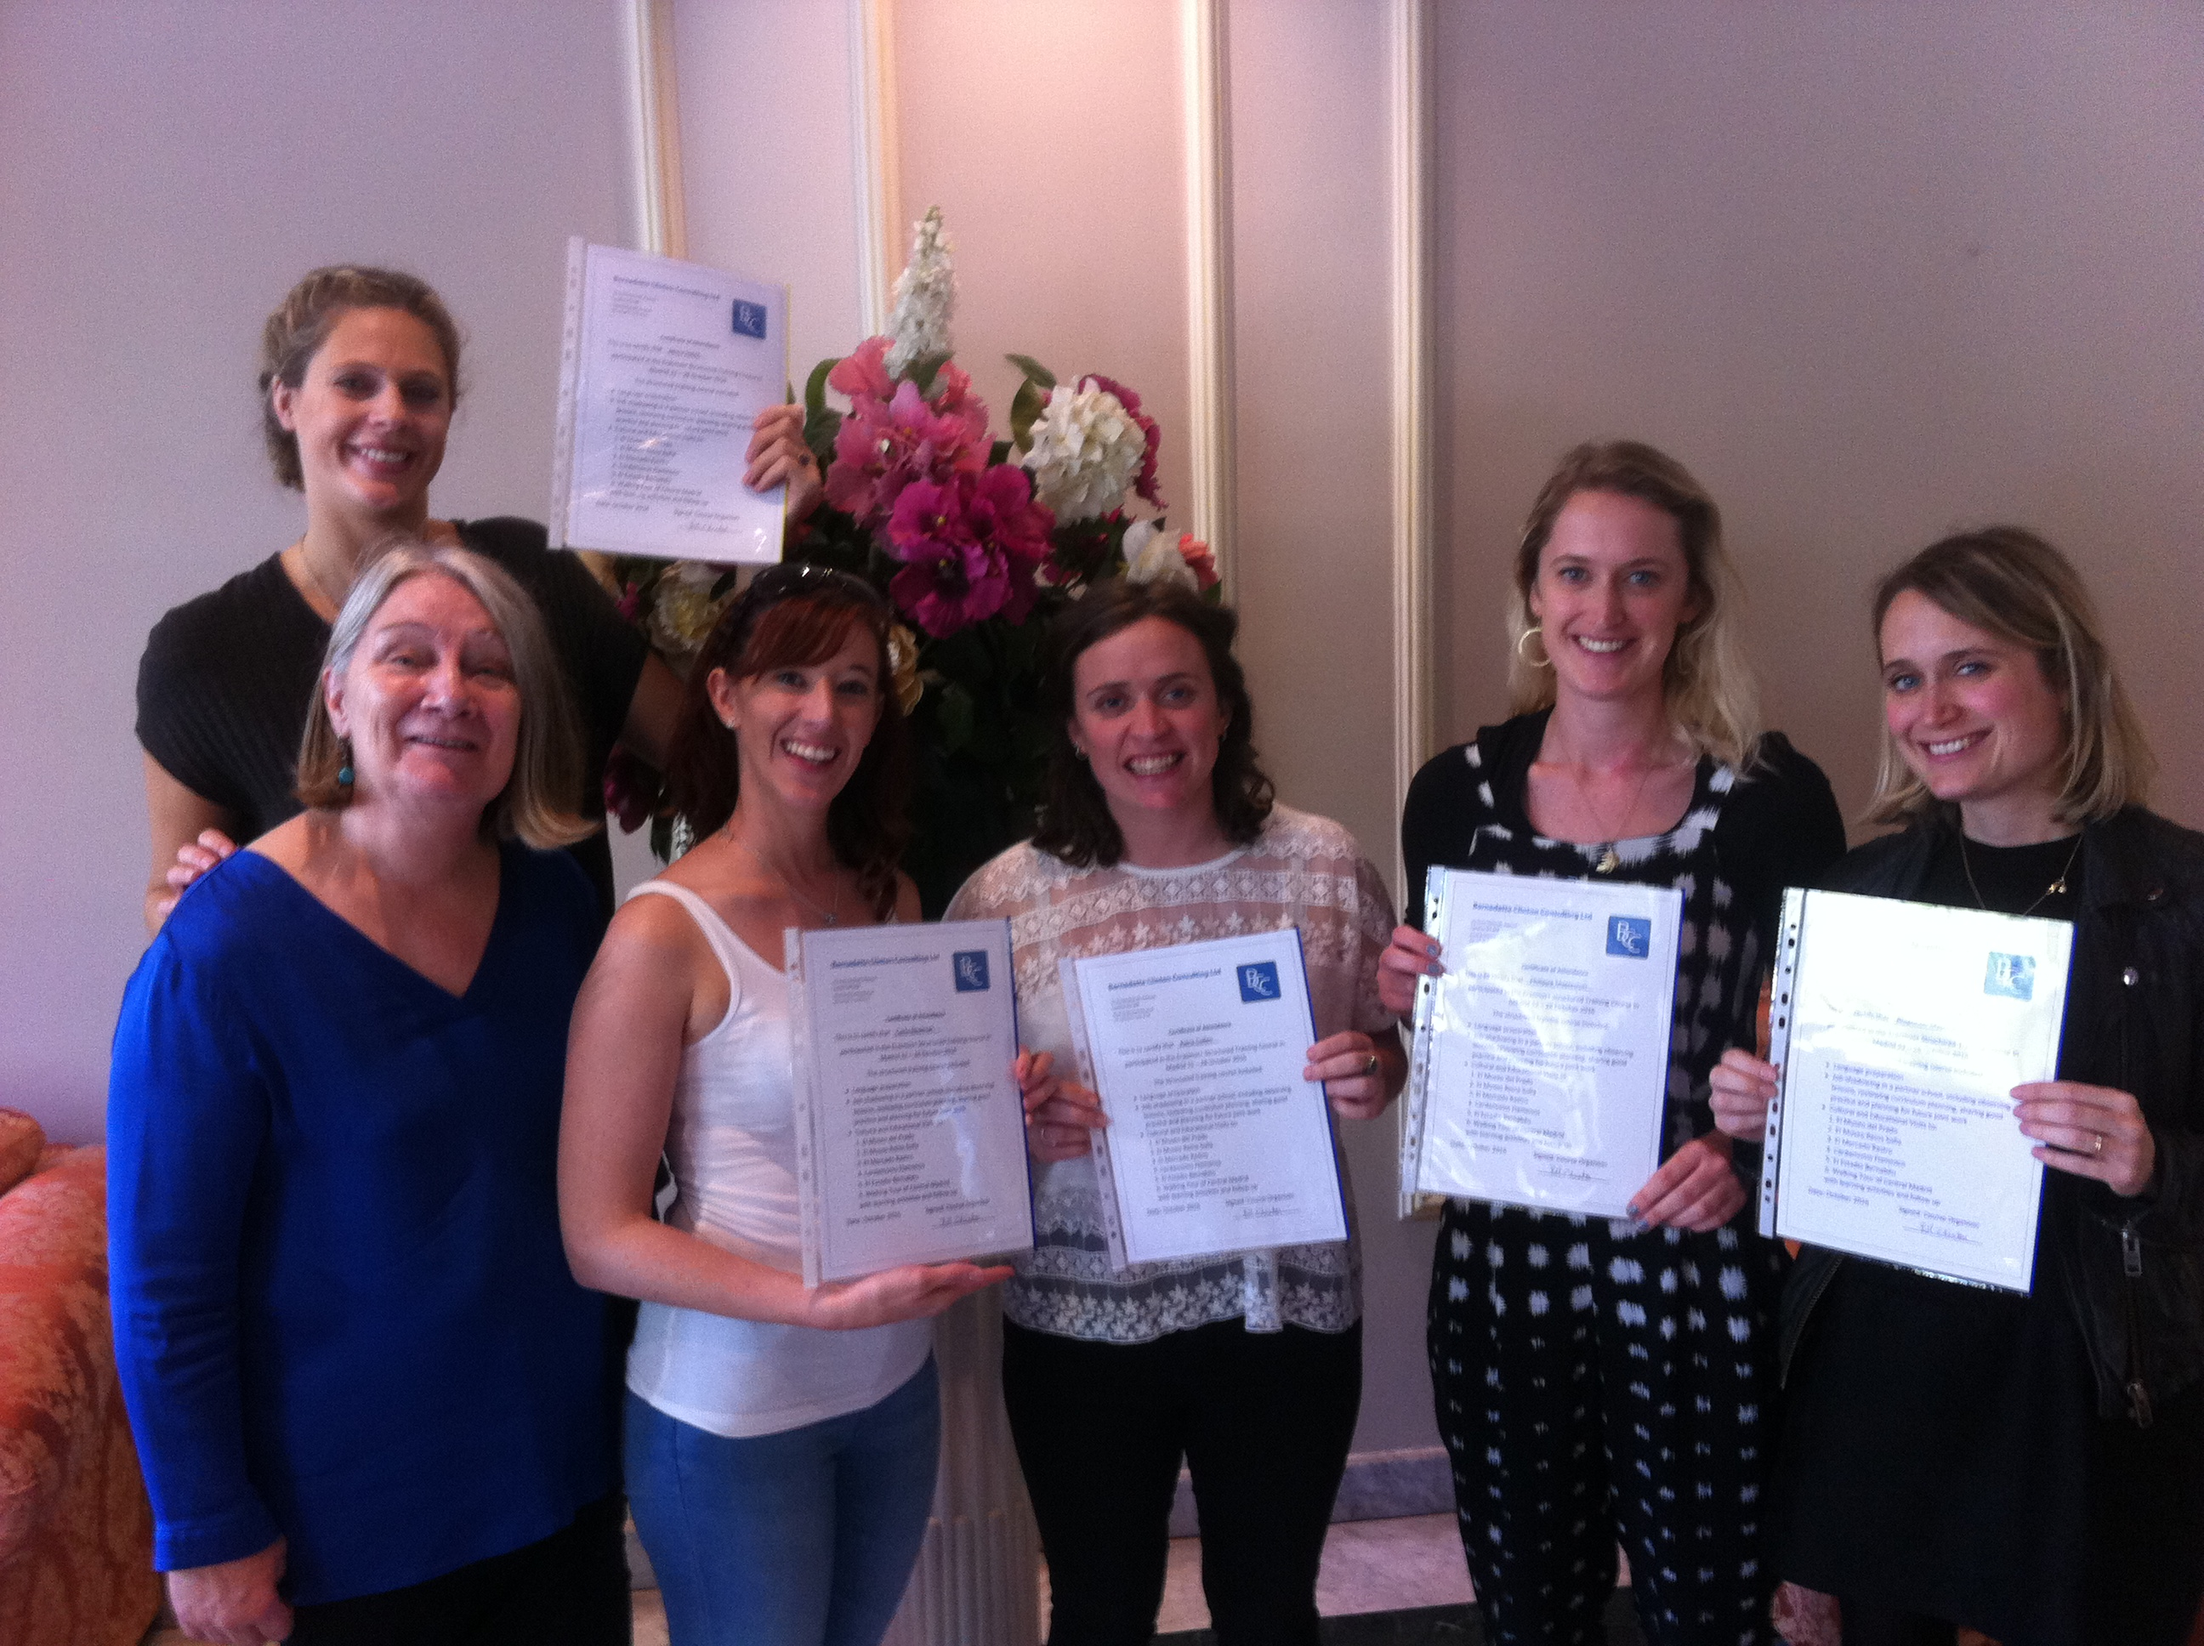
“Great language teacher – very well organised – great range of activities and networking opportunities”
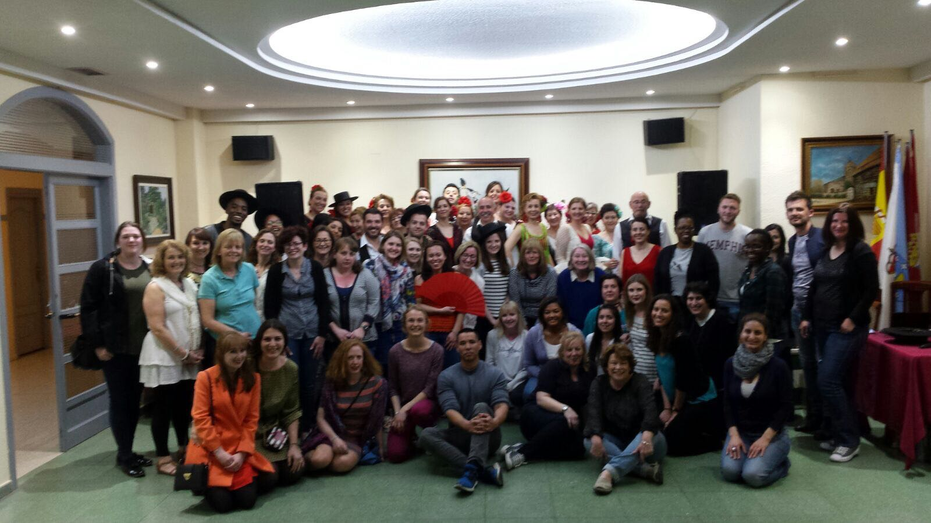

“Culturally and historically very interesting… great to see the contrast between Salamanca and Madrid”
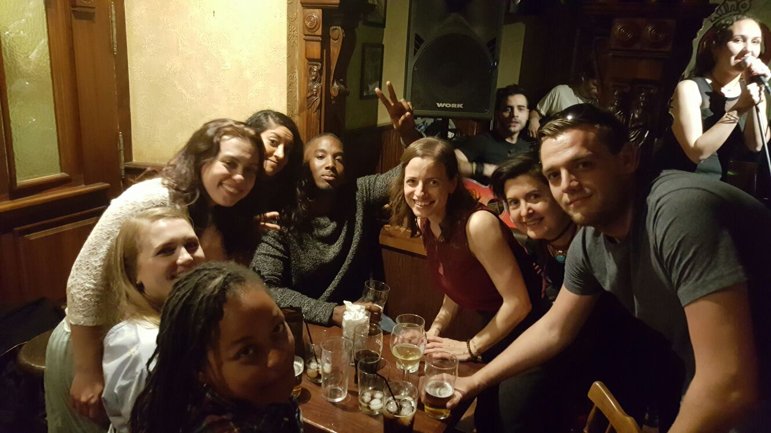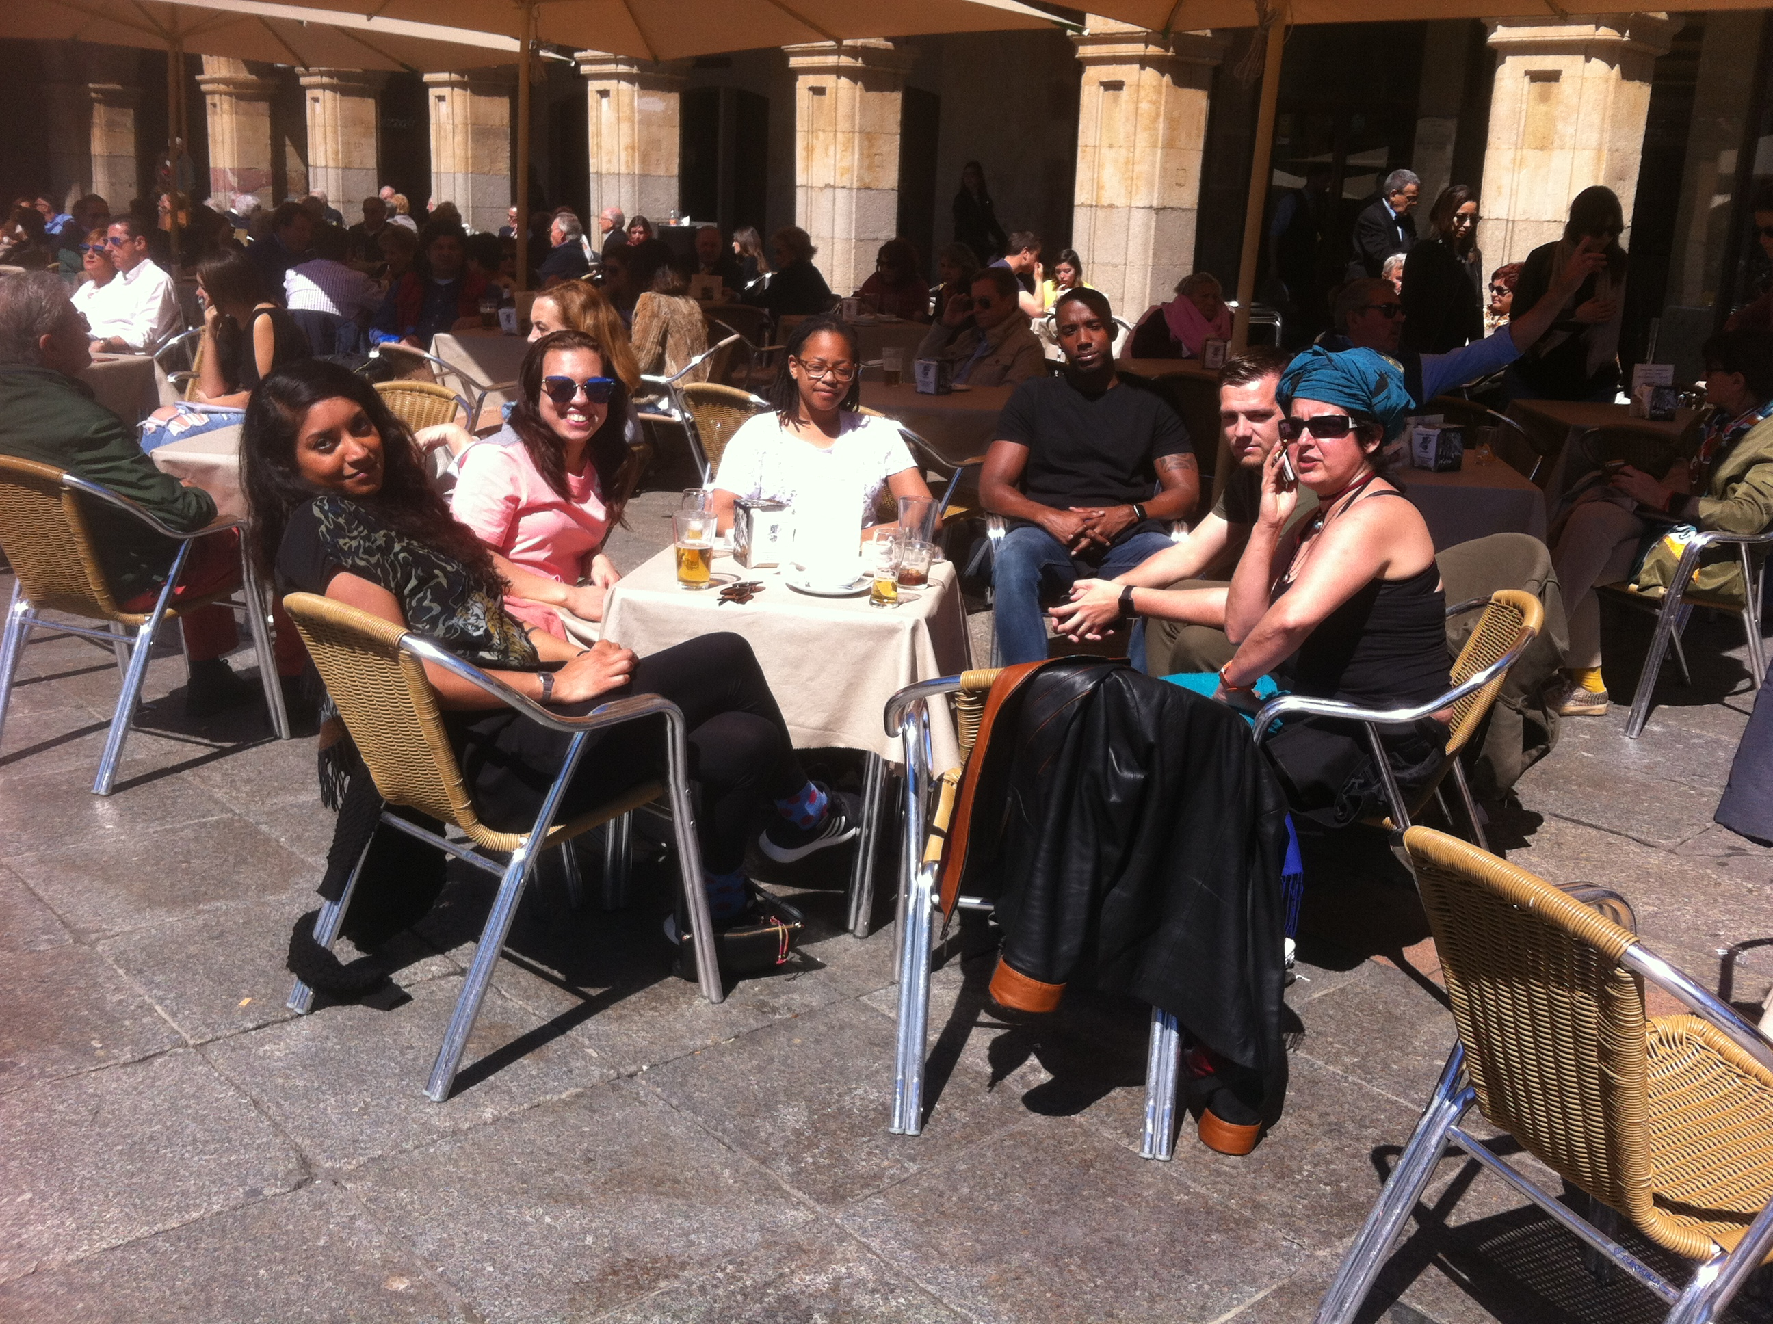

For all further information, please contact:

Bernadette Clinton
 www.bcclanguages.co.uk
 b.clinton@mdx.ac.uk
 @bcclanguages

