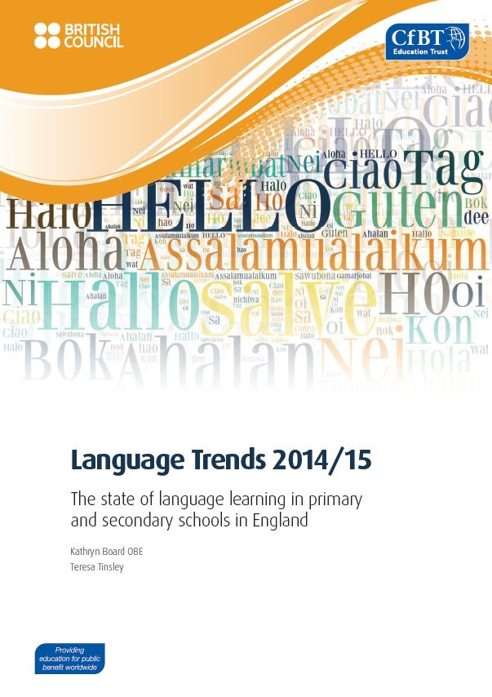
Date: 18 March 2015
The Language Trends survey, carried out in partnership between CfBT Education Trust and the British Council, charts the health of language teaching and learning in schools in England.
This year's report focuses particularly on the initial impact of compulsory status for languages in Key Stage 2 which was introduced in September 2014, and on continuing concerns about the number and profile of pupils who study a language beyond the compulsory phase in secondary schools. Concern about the drop in the number of pupils taking A levels in language subjects gave rise to two separate inquiries by national bodies in 2014. This report probes further into the issues raised.
Other key findings highlighted in the 2014/15 report are:
- French is overwhelmingly the language most frequently taught in schools followed by German and Spanish - only Spanish is expanding, but more slowly than the rate of decline for French and German. French is declining more rapidly in the independent sector than in state schools.
- The report shows that primary and secondary schools in both the independent and state sectors are only able to provide limited continuity when it comes to language teaching with just over half of independent schools and less than a third of state schools surveyed able to offer pupils the same language they studied at primary school at secondary level.
- GCSE is the highest level of linguistic ability amongst staff in 31 per cent of primary schools - a seven per cent increase on last year's survey.
- There is concern amongst secondary teachers about the wide variation in quality of provision of language teaching at Key Stage 2 including whether many primary schools have the ability to deliver what they regard as a worthwhile level of language knowledge that pupils can apply to their studies in secondary school.
The Language Trends Survey 2014/15 is the 13th in a series of annual research exercises. The research is based on an online survey completed by teachers in over 500 state secondary schools, over 600 state primary schools and over 120 independent secondary schools across the country. This year, case studies from both primary and secondary schools have been included for the first time to provide a more detailed picture of what is happening on the ground in a wide variety of settings and locations.
The research behind this year's survey was carried out under the joint management of the British Council and CfBT Education Trust between September and December 2014.

